# CPT_Logo_Manual.jpg Managing SharePoint Search & Sandbox Solutions

**Lab Time**: 60 minutes

**Lab Overview:** In this lab you will practice configuring Site Collection level search settings. You will learn to create new search scopes and employ search keywords. In addition you will learn how to deploy and activate sandbox solutions.

## Exercise 1: Configuring Search Settings

In this exercise you will practice managing the search settings of a site collection.

1. Log into your site collection using the account **Ken Sanchez**, the site collection administrator
2. Using Internet Explorer, browse to the URL of the SharePoint site collection you were provided to use when working on the hands on labs in this course.
3. When prompted to login, enter [[AD-DOMAIN]]\ken in the **User Name** field and click **OK**. Use the password specified in the *Hands-On Lab Overview* document provided in the student manual.
4. Create a Search Center with tabs for the Wingtip Team site collection:
5. Click the **Site Actions** hyperlink in the upper left corner of the page.
6. Click the **New Site** link from the resulting Site Actions drop-down menu.
7. In the resulting **Create** pop-up window scroll down to the bottom of the template listing and click on the **Enterprise Search Center** button to select the template.

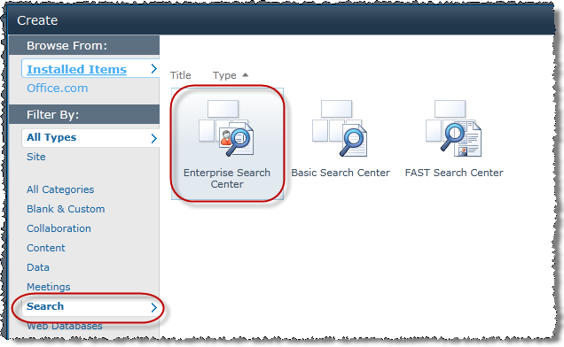

**Note**: If you try to create a site with this template, make sure the site collection Feature SharePoint Server Publishing Infrastructure has been activated. If not, you will receive an error during the site provisioning process.

1. In the right pane of the window, the Enterprise Search Center template name and description should appear with the opportunity to create a new site with all default values by simply entering a title and URL value. Read the site description then click the **More Options** button to customize the site creation values. Use the following values to create the search site
2. The left pane of the window should have changed from a listing of different template choice buttons to the options page for a new Search Center site. Fill in the values according to the Wingtip team's agreement as follows and click **Create**:

**Title:** Search Center

**Description:** Wingtip Team Search Center

**URL Name:** SearchCenter

**User Permissions:** Use same permissions as parent site

**Use the top link bar from the parent site?** No

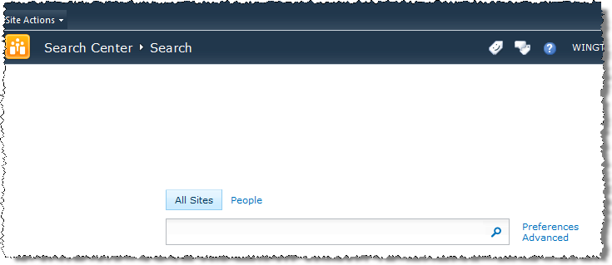

1. Navigate to the home page of Wingtip Team Site:
2. Notice the lack of navigation tools on a Search Center site template. Click the **Site Actions** hyperlink in the upper left corner of the page.
3. Click the **View All Site Content** link from the resulting Site Actions drop-down menu.
4. Click the **Wingtip Team Site** hyperlink in the Top Link Bar.
5. Alter the site collection Search settings to begin showing a scope drop-down menu on search boxes:
6. Click the **Site Actions** hyperlink in the upper left corner of the page.
7. Click the **Site Settings** link from the resulting Site Actions drop-down menu.
8. Click the **Search Settings** link under the **Site Collection Administration** header.

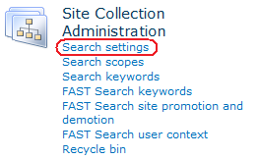

1. Change the **Site Collection Search Center** setting to the first radio button selection **Enable custom scopes...**. Now, the URL you enter needs to be root relative to the domain you’re in. The Search Center site you created is inside the current site collection at /SearchCenter/Pages. However this would not work for any site collection that does not live at the root of the Web application. Look at your site collection’s root URL and remove the domain portion. For instance, if your site collection URL was http://www.foo.com/sites/SomeSiteCollection, you should put the following in this textbox: /sites/SomeSiteCollection/SearchCenter/Pages.

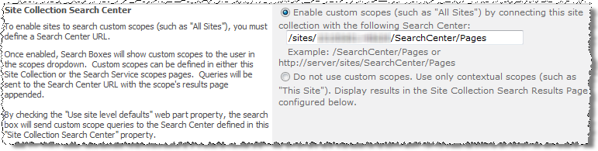

1. Change the **Site Collection Search Dropdown Mode** to **Show scopes dropdown**. Click **OK**.

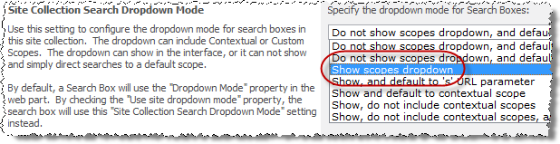

1. Navigate back to the home page of Wingtip Team Site via the breadcrumb trail.
2. Verify that a scope drop-down menu now appears before the search textbox in the upper right corner of the page and that it contains at least the **This Site: [site name]**, **All Sites** and **People** scopes as choices.

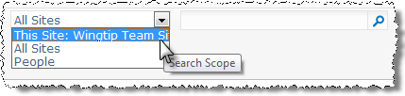

**Note:** It may take up to 15 minutes for the new scopes to show up in this drop down as the search service has a timed update mechanism that you may have to wait for it to complete to see your changes.

1. Test the new scope menu:
2. Click the scope drop-down menu and select **People**.
3. Enter **Michael** into the search field and click the **magnifying glass** to engage the search engine.



1. On the **Search results** page, notice that the results are limited to **Profile** information about Michael thanks to the People scope.

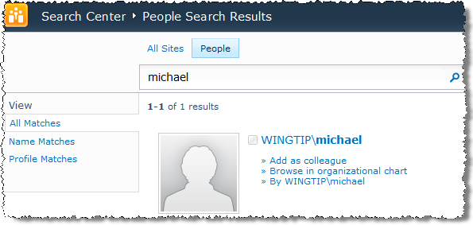

1. Navigate back to the home page of the Wingtip Team Site.
2. Click the scope drop-down menu and select **This Site**.
3. Enter **Michael** into the search field and click the **magnifying glass** to engage the search engine.
4. On the **Search results** page, notice that the results now include documents and items that have been created or modified by Mike.

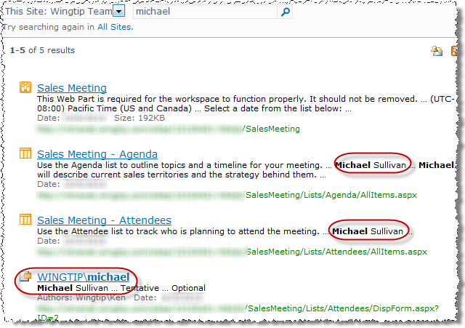

In this exercise you learned to manage the Search settings of a site collection.

## Exercise 2: Customizing Security

In this exercise you will practice creating new Search scopes.

1. Navigate back to the **Wingtip Team Site** site collection using your preferred method.
2. The Wingtip Team has requested a new Search scope that limits their results to only the data that resides on the Manufacturing site:
3. Click the **Site Actions** hyperlink in the upper left corner of the page.
4. Click the **Site Settings** link from the resulting Site Actions drop-down menu.
5. Click the **Search Scopes** link under the **Site Collection Administration** header.
6. Click the **New Scope** button in the toolbar:

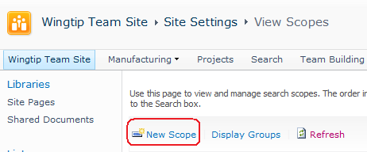

1. Create a new **Search scope** as follows:

**Title:** Manufacturing

**Description:** Use this scope to receive results of only those items from the Manufacturing site.

**Display Groups:** Search Dropdown & Advanced Search

**Target Results Page:** Use default Search Results Page

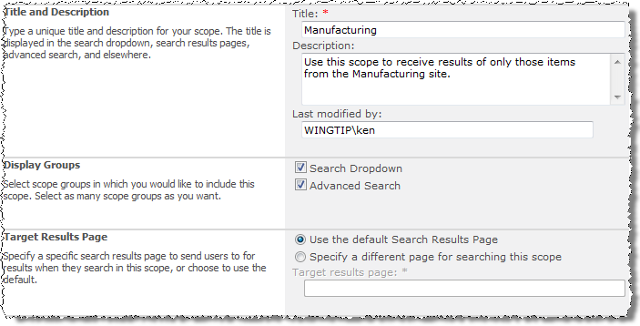

1. On the resulting **View Scopes** page, verify the new **Manufacturing** scope appears under both the **Search Dropdown** heading and the **Advanced Search** heading. Also notice there are no items in the scope. That is because no rules have been applied to tell the search scope what to include.

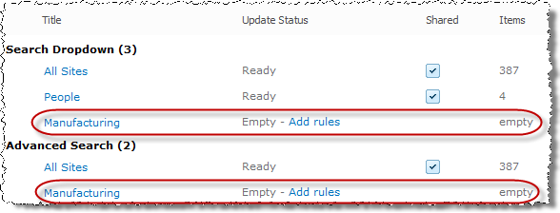

1. Click the **Add Rules** hyperlink to the right of the **Manufacturing** entry in the **Search Dropdown** header. Create a new rule using the following information and click **OK**.
2. Configure a rule for the new scope that includes entries from the Manufacturing SharePoint site only and click **OK**:

**Scope Rule Type:** Web Address

**Web Address (Folder):** http://[your site collection URL]/Manufacturing

**Behavior:** Include

**Tip**: The **Manufacturing** site should be in the Top Navigation Bar. Hold [SHIFT] and click it to open it in another browser. Copy the URL into the **Web Address / Folder** textbox and remove the /SitePages/Home.aspx.

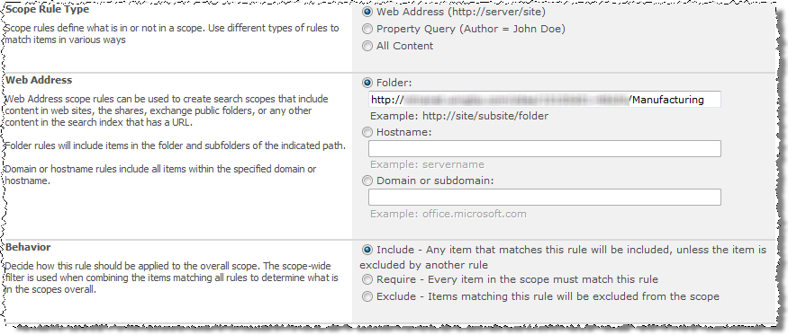

1. Notice that back on the **View Scopes** page the new **Manufacturing** scope may still be unavailable and reflect a time wait until it becomes useable.

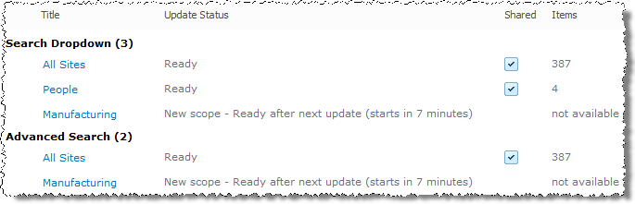

**Note**: In your environment you could contact a SharePoint Farm Administrator who could go into the Central Administration site and trigger the scopes to update immediately within the Search Service Application.

1. Use the **Refresh** link in the toolbar to periodically refresh your page until the new **Manufacturing** scope no longer reflects a state of **not available**.

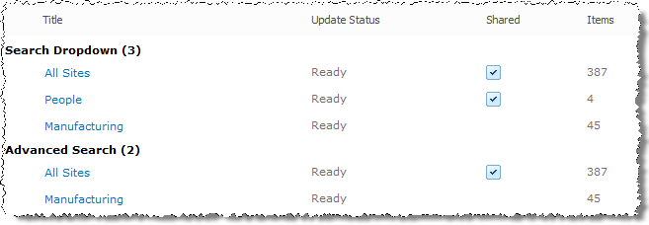

1. Test the new Manufacturing search scope:
2. Navigate to the home page of the Wingtip Team Site via your preferred method.
3. Verify that a scope drop-down menu now contains **Manufacturing** as a choice.

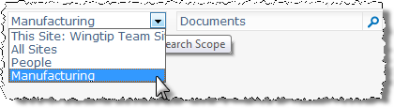

1. Select the **Manufacturing** scope, enter **Documents** into the search field and click the **magnifying glass** to engage the search engine.
2. On the **Search results** page, notice that the results are limited to data from the **Manufacturing** site thanks to the new **Manufacturing** scope limit.

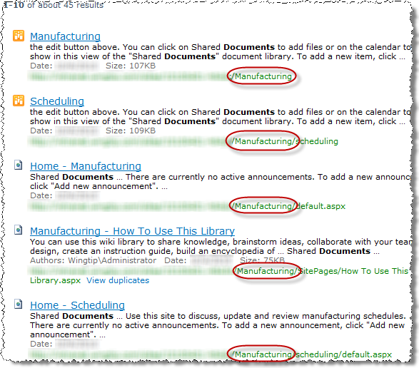

1. Navigate back to the home page of the Wingtip Team Site.

In this exercise you practiced creating new Search scopes.

## Exercise 3: Creating Search Keywords

In this exercise you will practice creating new Search keywords.

1. Create a new keyword for the Wingtip History document:
2. Click the **Site Actions** hyperlink in the upper left corner of the page.
3. Click the **Site Settings** link from the resulting Site Actions drop-down menu.
4. Click the **Search keywords** link under the **Site Collection Administration** header.
5. Click the **Add Keyword** button in the toolbar.

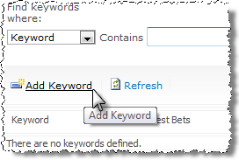

**Note:** Make sure you have a document named “**Wingtip History.docx**” in the Shared Documents library on the Wingtip Team Site (the top level site) before performing the following step.

1. Use the following information to create a new keyword that maps to the historical information document and click **OK**:

**Keyword phrase:** archives

**Synonyms:** companyhistory

**Add Best Bet:** [your site collection URL]/Shared%20Documents/Wingtip%20History.docx

**Title:** Wingtip Corporate History

**Description:** Wingtip History document from team site.

**Keyword Definition:** Click here to read about the history of Wingtip Toys! Ours is a rich history of a small family business that went global.

**Contact:** Ken Sanchez

1. Test the new keyword **archives**. Navigate back to the Wingtip Team Site and search for the term **archives** using the **This Site** scope:



1. On the **Search results** page, notice that the **Wingtip History** document from the **Shared Documents** library on Wingtip Team Site appears with a yellow star indicating it is very likely to be the item that you, the user performing the search, will most benefit from.

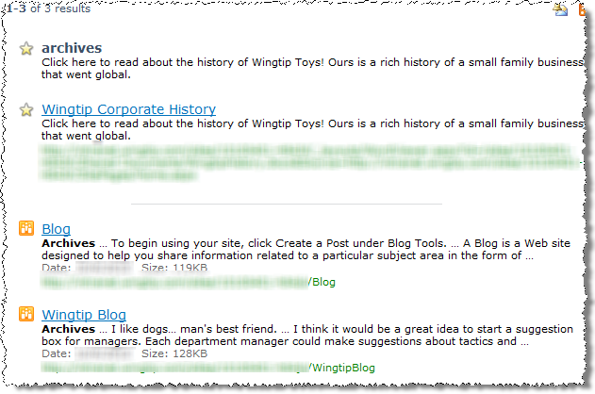

In this exercise you practiced creating new Search keywords.

## Exercise 4: Working with Sandbox Solutions

In this exercise you will learn how manage custom sandbox solutions.

1. Log into your site collection using the account **Ken Sanchez**, the site collection administrator
2. Using Internet Explorer, browse to the URL of the SharePoint site collection you were provided to use when working on the hands on labs in this course.
3. When prompted to login, enter [[AD-DOMAIN]]\ken in the **User Name** field and click **OK**. Use the password specified in the *Hands-On Lab Overview* document provided in the student manual.
4. Typically sandbox solutions are provided by a developer to the site collection administrator. In this lab one has already been added to site collection. To simulate a near-production experience you will download and delete the deployed version to start fresh:
5. From the Wingtip Team Site, use the ribbon to select **Site Actions » Site Settings**.
6. Under the **Galleries** section, select the **Solutions** link.

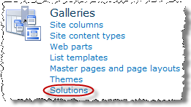

1. Within the **Solution Gallery** you will see a single sandbox solution: **SandboxDateTimeWebPart**. Click the link to download the solution to your desktop:

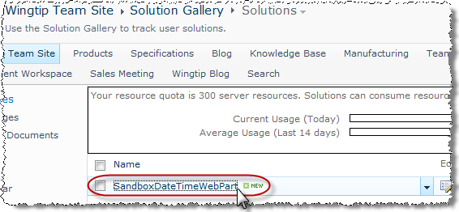

1. Once the solution has been downloaded, delete it from the Solution Gallery using the ECB Menu to delete it:

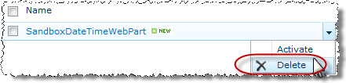

1. Now upload the sandbox solution just like it was recently received from a developer or from a vendor:
2. Go back to the **Solution Gallery** in the browser and select the **Solutions** tab in the ribbon. Click the **Upload Solution** button:

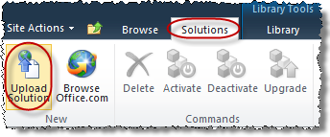

1. The Upload Solution process is identical to uploading a document to a document library. Upload the SandboxDateTimeWebPart.wsp file to the Solution Gallery.
2. After uploading the solution, you are presented with a dialog where you can activate the solution. Click the **Activate button** within the **Commands** group of the **View** tab in the ribbon:

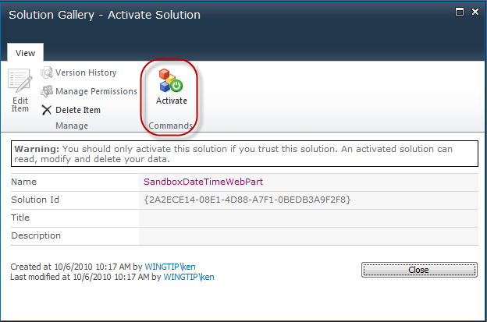

The activation of the solution automatically activated any site collection scoped Features that the solution may have contained. Because this solution contains a Web Part, and a Web Part must be deployed and provisioned with a site collection scoped Feature, everything has been done that is needed to use the Web Part.

1. Now it is time to add the Web Part to a few pages. First add it to a Wiki Page:
2. Use the breadcrumb trail to go back to the Wingtip Team Site home page.
3. Using the ribbon, select **Page** the page tab and the click the **Edit** button.
4. Using the ribbon, add the sandbox Web Part to the page: From the **Editing Tools** contextual tab group, select the **Insert** tab and click the **Web Part** button:

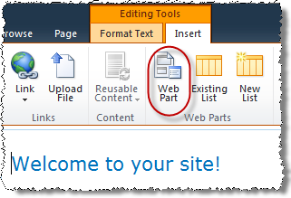

1. Look in the **Critical Path Training** category for the **Sandbox Date/Time Web Part**. Select this Web Part and click the **Add** button to add it to the **Rich Content** zone on the page:

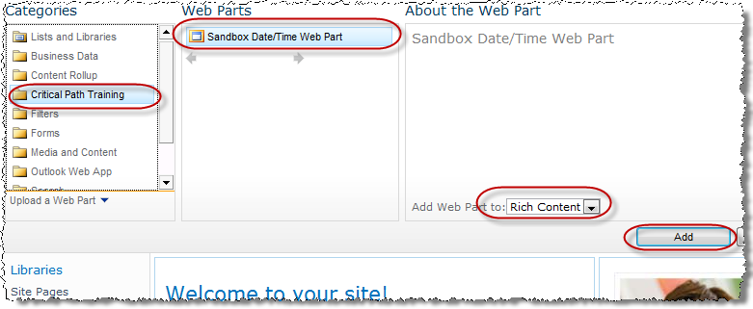

1. Once the Web Part is on the page…

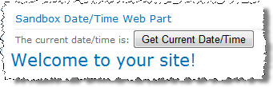

… click the **Get Current Date/Time** button to see the current date/time written to the page.

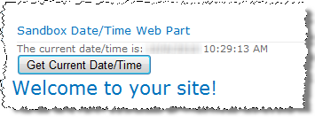

1. It is obvious this Web Part is working.
2. Save the page by clicking the **Save & Close** button in the **Page** tab in the ribbon.
3. Now add the Web Part to a SharePoint Web Part Page. Modify the URL of your site to go to the traditional Web Part Page that acts as a home page for all sites that are not using the Site Pages library. Do this by removing the /SitePages/Home.aspx from the URL and replacing it with default.aspx:
4. Add the Web Part in the sandbox solution to the Web Part page:
5. Put this page in edit mode by clicking the **Edit** button in the **Page** tab in the ribbon:

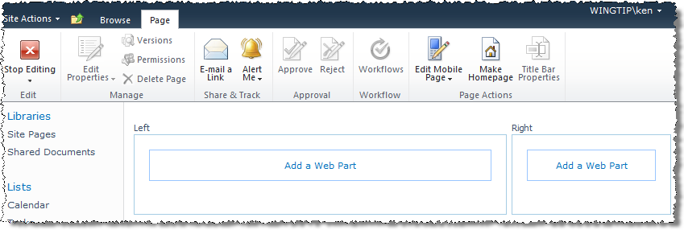

1. Click the **Add a Web Part** link in the **Left Web Part Zone** to add a Web Part to the page.
2. Select the same **Sandbox Date/Time Web Part** and add it to the **Left Web Part Zone** on the page:

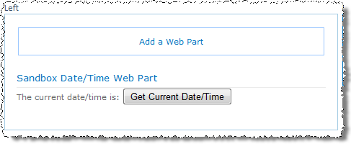

1. Leave edit mode by clicking the **Stop Editing** button in the **Page** tab of the ribbon.
2. Test the Web Part by clicking the **Get Current Date/Time** button.
3. At this point the sandbox Web Part has been uploaded, activated, deployed and added to two pages on the site. Now lets go ahead and deactivate the sandbox solution.
4. Select **Site Actions » Site Settings** from the ribbon.
5. From the **Galleries** section, select **Solutions**.
6. Notice that the **Resource Usage** of the **SandboxDateTimeWebPart** is reported as **0.00**. This isn’t because monitoring is disabled, it is because this solution is hardly doing any work so it hasn’t accumulated any points yet.
7. Select the **SandboxDateTimeWebPart** and click the **Deactivate** button in the **Solutions** tab in the ribbon:

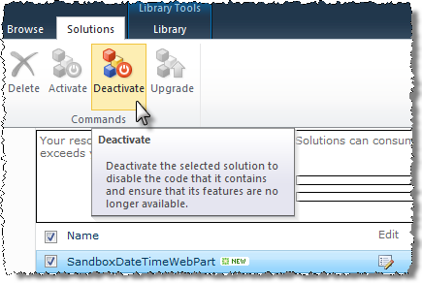

1. This will launch a dialog prompting you to deactivate the solution. Go ahead and do this. When the **Solution Gallery** refreshes you’ll notice the Status is no longer **Activated**.

With the sandbox solution deactivated, the Web Part that it contains is no longer allowed to run.

1. Go back to the homepage of the Wingtip Team Site using the breadcrumb or Top Navigation Bar.
2. Notice the Web Part is showing an error saying the solution was not found:

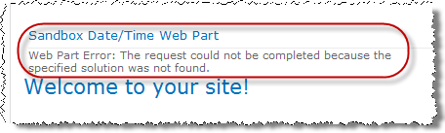

1. If you visited the same Web Part Page you added the Web Part to (the non-wiki page), you will see the same error. To remove this error, put the page in edit mode and remove the Web Part from the page.

In this exercise you learned how manage custom sandbox solutions.